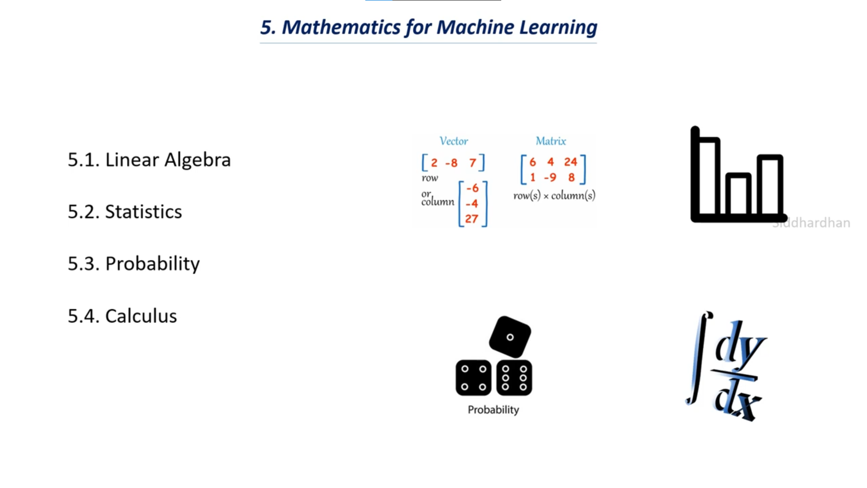

# Linear Algebra

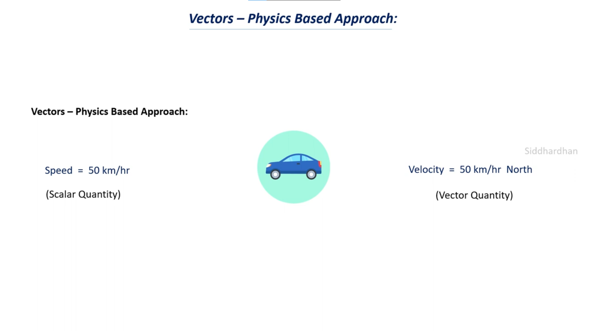

Look at Notebook.

# Vector Operation (part 2)

**Python Command:**

# Matrix – Basic (Linear Algebra)

